MySQL Question for Dairy Dataset
Q1: Total revenue generated by each product
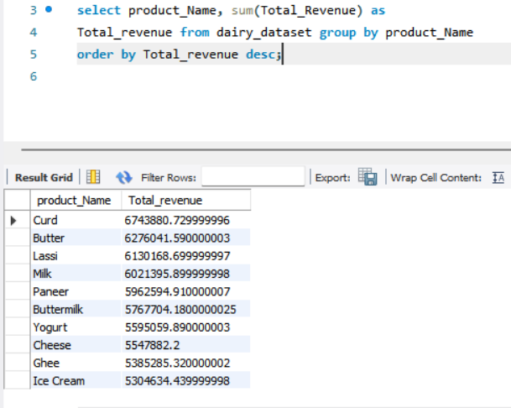
Q2: Give Brand with the highest total revenue
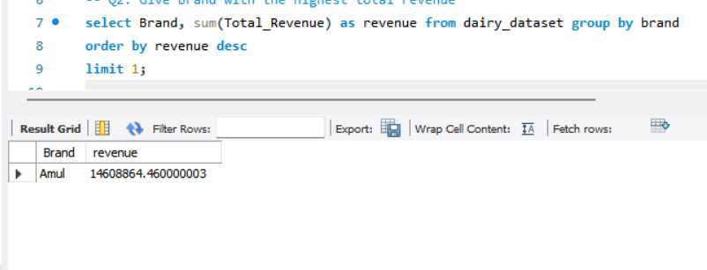
Q3: Give Monthly revenue trend across all products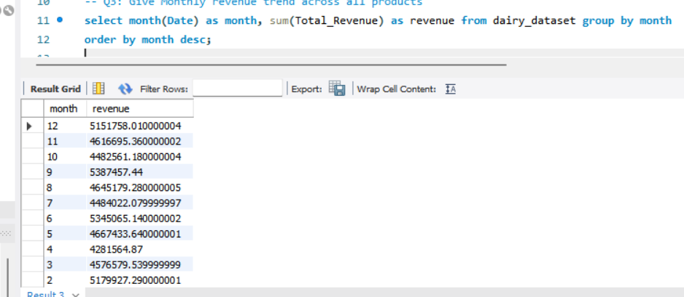
Q4: Products below the minimum stock threshold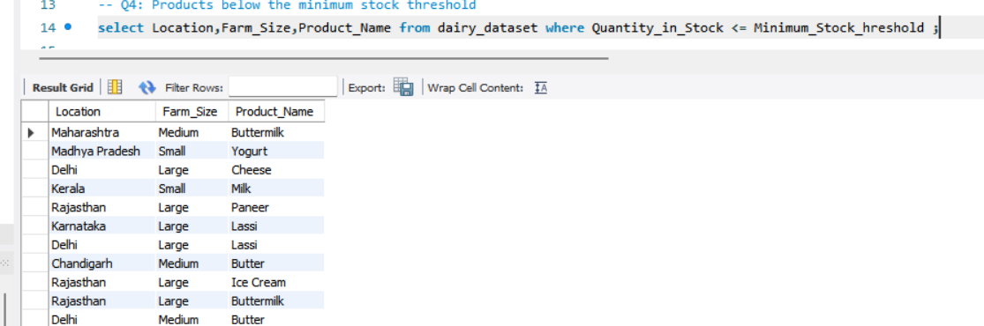
Q5: Total reorder quantity required per product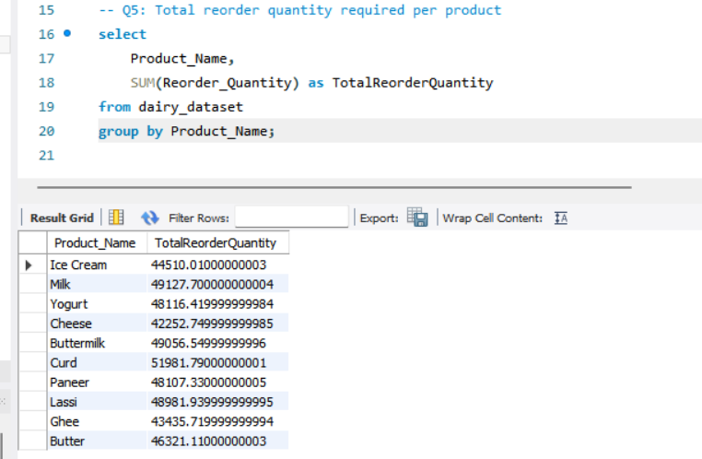
Q6: Which sales channel generates the most revenue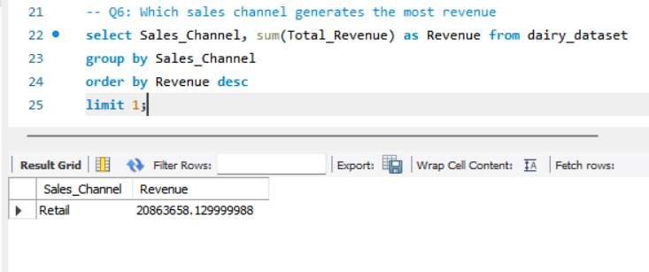
Q7: Top 5 customer locations by purchase volume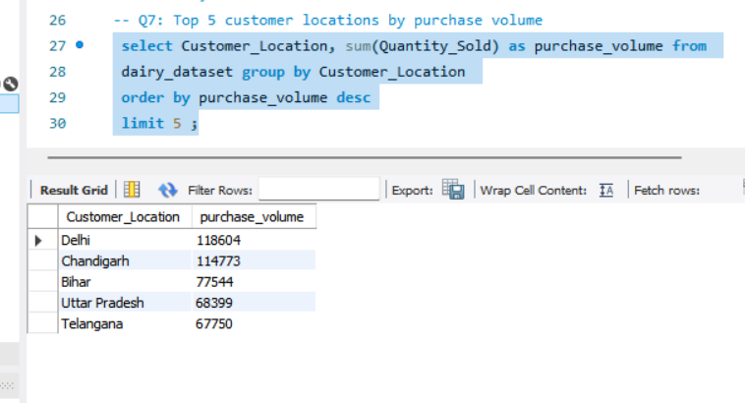
Q8: Average selling price per product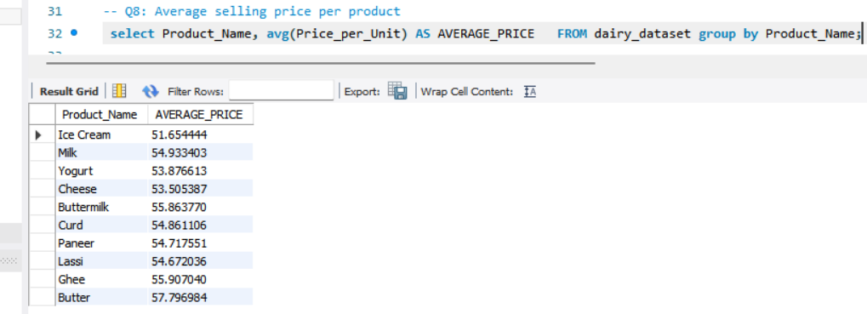
Q9: Compare selling price with listed price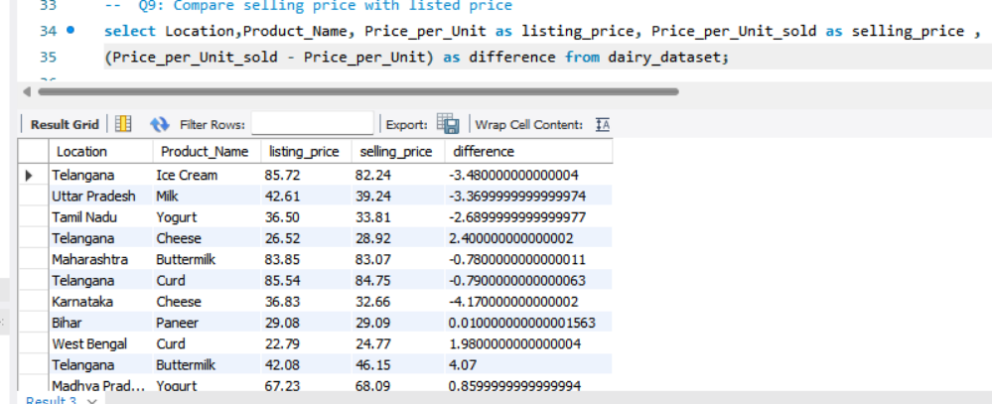
Q10: Products with less than 10 days shelf life remaining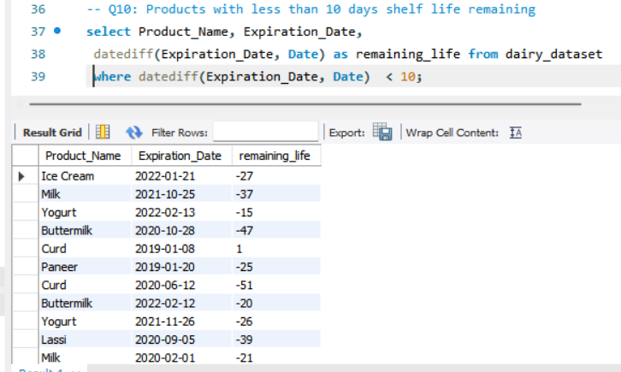
Q11: Average shelf life by product category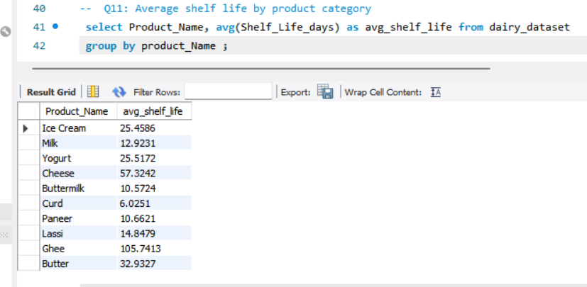
Q12: Average number of cows per farm size category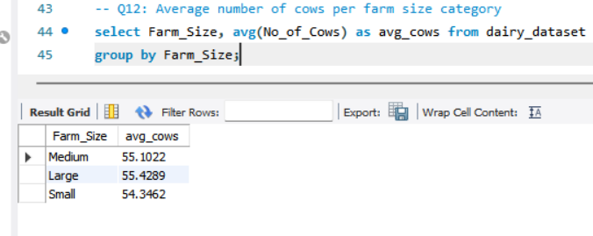
Q13: Location with the largest total land area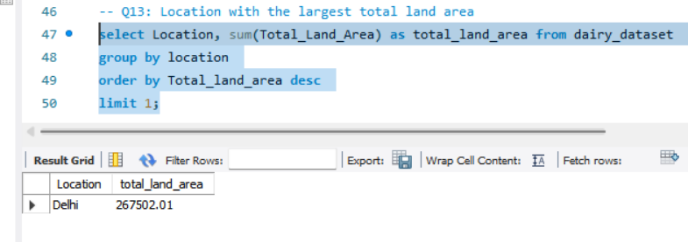
Q14: Top 3 locations by average production quantity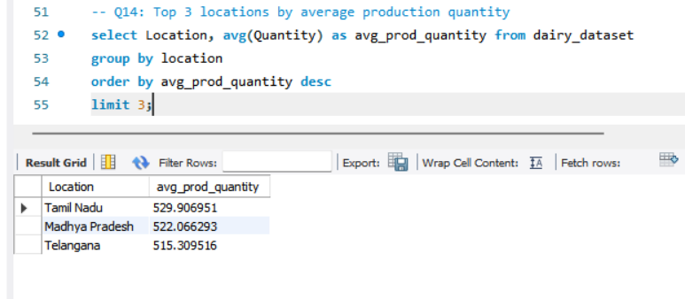
Q15: Calculate profit for each product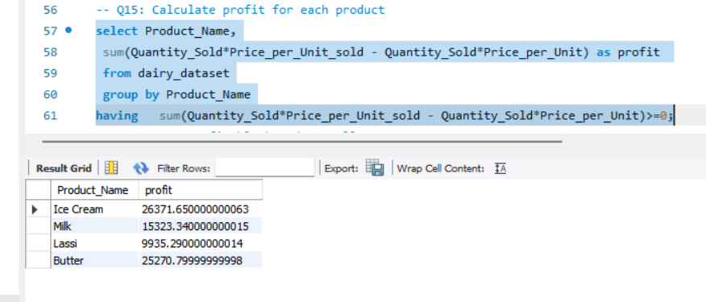
Q16: Most profitable brand overall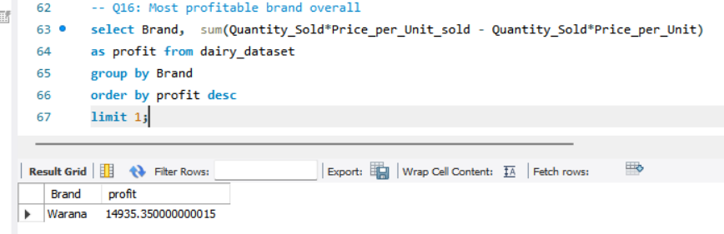
Q17: Yearly revenue growth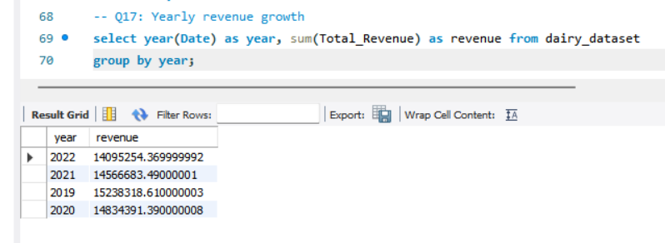
Q19: Products that need immediate restock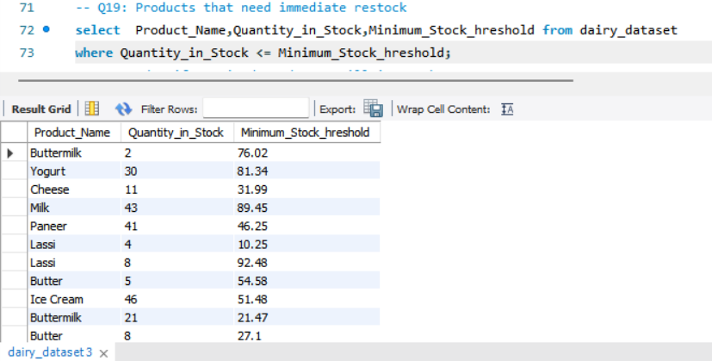
Q20: Identify expired products still in stock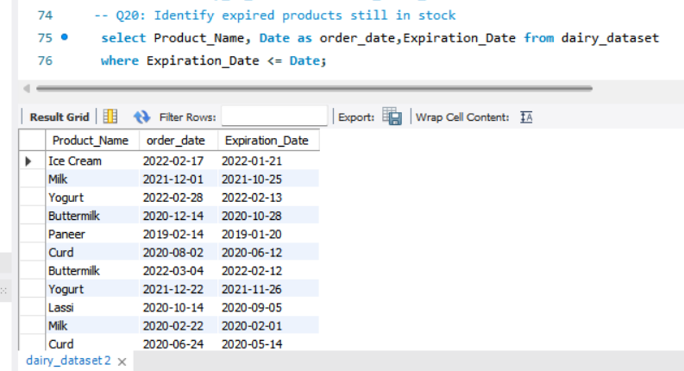

Q21: Average shelf life per brand